WHO oPt updates
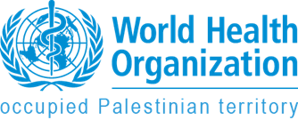

WHO delivers medical supplies to scale up pre-hospital trauma care in Gaza

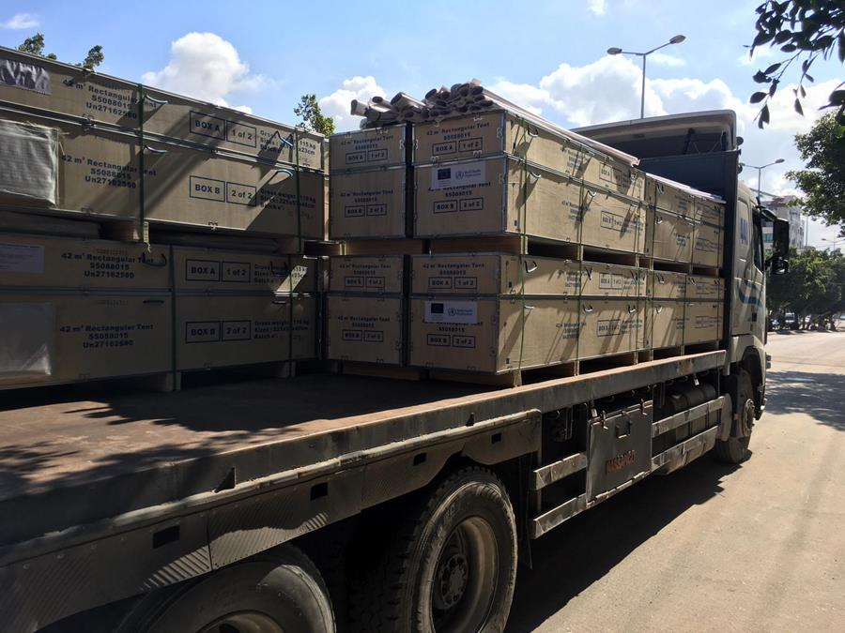

24 March 2019 - The World Health Organization (WHO) delivered essential medicines, medical consumables and equipment to respond to the growing trauma and emergency care needs in the Gaza Strip. The shipment was possible through a generous contribution from the European Union.
Supplies delivered by WHO will be used to enhance the ability of the 10 trauma stabilization points (TSPs), run by Ministry of Health and the Palestine Red Crescent Society, to provide life- and limb- saving care to those injured during demonstrations and protests. Interventions provided at the TSPs are of vital importance as trauma casualty rates remain high and the resources available in Gaza are scarce. In response, WHO works to strengthen all levels of trauma management and to ensure that at the pre-hospital level, the TSP teams have vital medicines and equipment for triage and initial treatment of the injured.
The shipment is sufficient to cover needs of about 120,000 mildly injured or 20,000 severely injured patients. In addition to medicines and medical supplies, WHO delivered four tents for each TSP to make sure the teams have adequate space to treat patients with different levels of trauma severity. 5 TSPs were equipped with generators to run basic services, such as oxygen provision for patients. WHO will also provide the TSP teams with inflatable tents that can be set up within minutes in case of emergency and provide the flexibility to be moved quickly to alternative locations to treat people in need.
“Resource gaps in trauma care may lead to preventable long-term disability or even worse health outcomes. WHO and humanitarian health partners are working together to ensure that TSPs have the capacity to stabilize patients, to decrease the risk of preventable trauma complications or the loss of limbs, and to ensure better health outcomes,” says Dr Gerald Rockenschaub, head of WHO’s office for the occupied Palestinian territory. “We are grateful to the European Union for their continuous support that helps us to support essential trauma services in the Gaza Strip.”
Currently, the majority of all trauma patients are passing through the trauma stabilization points, where almost half of them are being treated and discharged while others receive the necessary care to stabilize them for the referral to the hospital for further interventions.
In addition to the massive existing trauma needs, the upcoming one-year anniversary of the Great March of Return may result in more casualties. WHO and health cluster partners developed a contingency plan to address the health needs within the 96-hours of a potential escalation of the situation in Gaza and to prevent death and disability. To further boost all levels of trauma care, WHO recently appealed for US$ 5.3 million.

